**LP Formulations: In-Class**

**In-class exercise I: Advertising Media Selection**

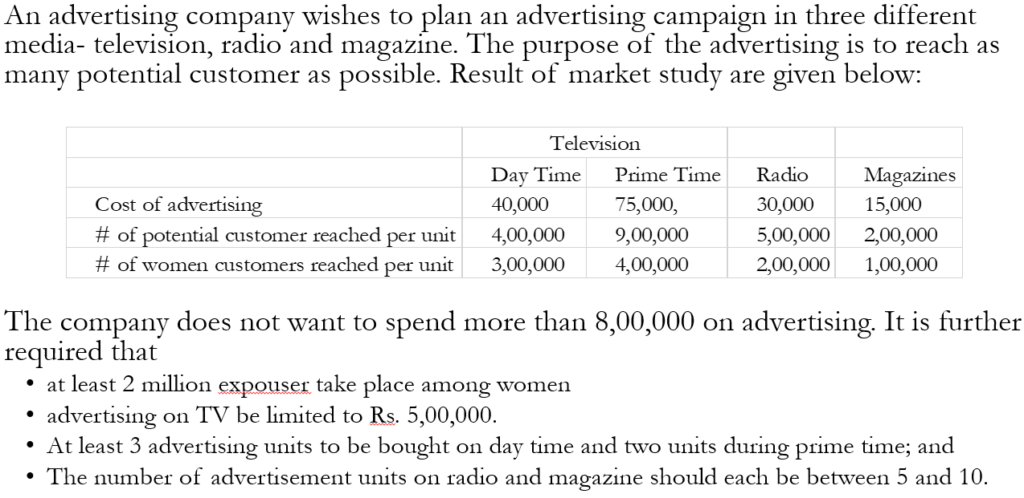



**In-class exercise II: Multiple period production-inventory model**

Acme Manufacturing Company has received a contract to deliver home windows over the next 6 months. The successive demands for the six periods are 100, 250, 190, 140, 220, and 110, respectively. Production cost for window varies from month to month depending on labor, material, and utility costs. Acme estimates the production cost per window over the next 6 months to be $50, $45, $55, $48, $52, and $50, respectively. To take advantage of the fluctuations in manufacturing cost, Acme may elect to produce more than is needed in a given month and hold the excess units for delivery in later months. This, however, will incur storage costs at the rate of $8 per window per month assessed on end-of-month inventory. Develop a LP to determine an optimum production schedule for Acme.

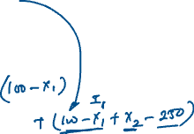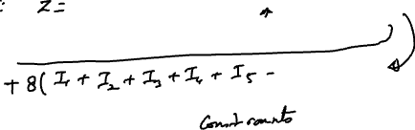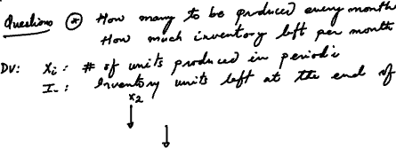

|  |  |  |
| --- | --- | --- |
| Type | Interest Rate | Bad debt Ratio |
| Personal | 0.140 | 0.10 |
| Car | 0.130 | 0.07 |
| Home | 0.120 | 0.03 |
| Farm | 0.125 | 0.05 |
| Commercial | 0.100 | 0.02 |

**In-class exercise III: Investment Decisions**

A bank is in the process of devising a loan policy that involves a maximum of Rs. 12 million. The following table provides the pertinent data about available loans. Bad debts are unrecoverable and produce no interest revenue. Competition with other financial institutions dictates the allocation of at least 40% of the funds to farm and commercial loans. To assist the housing industry in the region, home loans must be at least 50% of the personal, car loans. The bank limits the overall ratio of bad debts on all loans to at most 4%.



**In-class exercise IV: Transportation Problem**

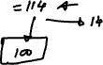

|  |  |  |  |  |  |
| --- | --- | --- | --- | --- | --- |
|  | 1 | 2 | 3 | 4 | 5 |
| A | 6 | 7 | 8 | 6 | 9 |
| B | 10 | 8 | 9 | 5 | 3 |
| C | 2 | 9 | 5 | 10 | 6 |

A company has manufacturing facilities at three locations (A, B, C) and a single product to be shipped to 5 customers. The capacities of plants A, B and C are 100 70, and 50 units, respectively. The firm must ship at least 60 units to customer 1 and 40 units to customer 2. Customers 3, 4, and 5 would require at least 10 units each but buy as many of the remaining units as possible. The net profit associated with shipping a unit from each plant to every customer is given below. The company wants to know how many units to ship to each customer from plants A, B, and C in order to maximize their profits. Formulate this as an LP problem.

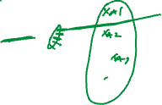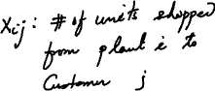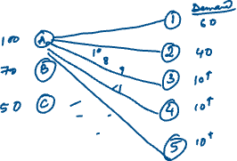

|  |  |
| --- | --- |
| Day | # required |
| 1: Monday | 17 |
| 2: Tuesday | 13 |
| 3: Wednesday | 15 |
| 4: Thursday | 19 |
| 5: Friday | 14 |
| 6: Saturday | 16 |
| 7: Sunday | 11 |

**In-class exercise V: Workforce Planning**

A post office requires different numbers of full-time employees on different days of the week. Union rules state that each full-time employee must five consecutive days and then two days off. The post office wants to meet its daily requirements using only full-time employees. Formulate an LP that the post office can use to minimize the number of full-time employees who must be hired.

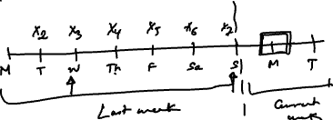

**In-class exercise VI: Cargo Assignment**

|  |  |  |
| --- | --- | --- |
| **Compartment** | **Weight Capacity (Tons)** | **Space Capacity (Cubic feet)** |
| Front | 12 | 7000 |
| Center | 18 | 9000 |
| Back | 10 | 5000 |

|  |  |  |  |
| --- | --- | --- | --- |
| **Cargo** | **Weight (Tons)** | **Volume (Cubic Feet/Ton)** | **Profit ($/Ton)** |
| **1** | **20** | **500** | **320** |
| **2** | **16** | **700** | **400** |
| **3** | **25** | **600** | **360** |
| **4** | **13** | **400** | **290** |

A cargo plane has three compartments for storing cargo: front, center, and back. These compartments have capacity limits on both weight and space, as summarized in the top table. Furthermore, the weight of the cargo in the respective compartments must be the same proportion of that compartment’s weight capacity to maintain balance of the Airplane. The four cargoes have been offered for shipment on an upcoming flight as space is available in bottom table. Any portion of this cargoes can be accepted. The objective is to determine how much (if any) of each cargo should be accepted and how to distribute each among the compartments to maximize the total profit for the flight.



Formulate this as an LP problem.

